Program 5 : Bar Chart, Pie Chart, Line Graph, Area Graph, Scatter Plot & Histogram using excel in Jupyter Notebook

**import** matplotlib.pyplot **as** plt

plt**.**bar(df['Students Roll no'], df['B.tech Percent'])

*# Adding labels and title*

plt**.**xlabel('Students Roll no') plt**.**ylabel('B.tech Percent')

plt**.**title('Bar Chart')

*# Rotating x-axis labels for better readability*

plt**.**xticks(rotation**=**45)

*# Display the plot*

plt**.**show()

In [5]:

**import** pandas **as** pd

excel_file_path **=** "C:\\Users\\ACER\\Desktop\\Lab5.xlsx" df **=** pd**.**read_excel(excel_file_path)

print(df)

|  |  |  |  |  |  |  |  |  |  |  |  |
| --- | --- | --- | --- | --- | --- | --- | --- | --- | --- | --- | --- |
|  | Students | Roll | no | B.tech | Percent | Class | 12 | Percent | Class | 10 | Percent |
| 0 |  |  | 1 |  | 86 |  |  | 90 |  |  | 99 |
| 1 |  |  | 2 |  | 95 |  |  | 87 |  |  | 75 |
| 2 |  |  | 3 |  | 50 |  |  | 56 |  |  | 82 |
| 3 |  |  | 4 |  | 76 |  |  | 77 |  |  | 43 |
| 4 |  |  | 5 |  | 65 |  |  | 75 |  |  | 93 |
| 5 |  |  | 6 |  | 90 |  |  | 45 |  |  | 56 |
| 6 |  |  | 7 |  | 56 |  |  | 93 |  |  | 72 |
| 7 |  |  | 8 |  | 63 |  |  | 46 |  |  | 68 |
| 8 |  |  | 9 |  | 83 |  |  | 88 |  |  | 59 |
| 9  In [7]: |  |  | 10 |  | 50 |  |  | 58 |  |  | 93 |

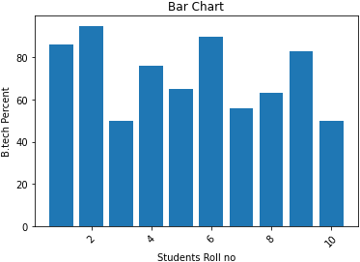

In [9]:

explode **=** [0.1] **\*** len(df)

plt**.**pie(df['Students Roll no'], labels**=**df['Class 12 Percent'], autopct**=**'%1.1f%%', ex

*# Adding title*

plt**.**title('Pie Chart')

*# Display the plot*

plt**.**show()

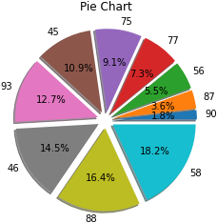

In [10]:

plt**.**plot(df['Students Roll no'], df['Class 10 Percent'], marker**=**'o', linestyle**=**'-')

*# Adding labels and title*

plt**.**xlabel('Students Roll no') plt**.**ylabel('Class 10 Percent') plt**.**title('Line Graph')

*# Rotating x-axis labels for better readability*

plt**.**xticks(rotation**=**45)

*# Display the plot*

plt**.**show()

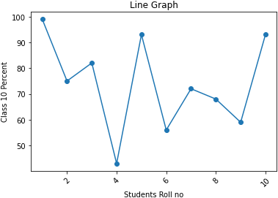

In [11]:

plt**.**fill_between(df['Students Roll no'], df['B.tech Percent'], color**=**"skyblue", alph plt**.**plot(df['Students Roll no'], df['B.tech Percent'], color**=**"Slateblue", alpha**=**0.6,

*# Adding labels and title*

plt**.**xlabel('Students Roll no') plt**.**ylabel('B.tech Percent')

plt**.**title('Area Graph')

*# Display the plot*

plt**.**show()

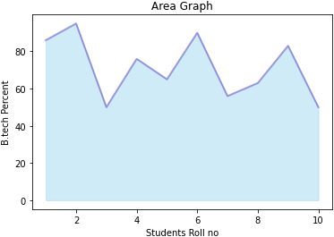

In [12]:

plt**.**scatter(df['Students Roll no'], df['B.tech Percent'])

*# Adding labels and title*

plt**.**xlabel('Students Roll no') plt**.**ylabel('B.tech Percent')

plt**.**title('Scatter Plot')

*# Display the plot*

plt**.**show()

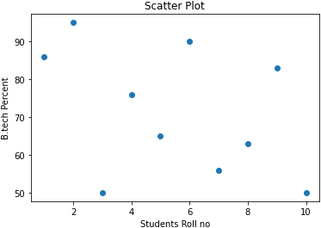

In [13]:

plt**.**hist(df['B.tech Percent'], bins**=**10, alpha**=**0.5, label**=**'B.tech Percent')

plt**.**hist(df['Class 12 Percent'], bins**=**10, alpha**=**0.5, label**=**'Class 12 Percent')

*# Adding labels and title* plt**.**xlabel('Percentage') plt**.**ylabel('Frequency')

plt**.**title('Histogram of B.tech Percent and Class 12 Percent')

*# Adding legend*

plt**.**legend()

*# Display the plot*

plt**.**show()

